Thoracic Spine & Costal Cage Lab Handout
1. Observation
Sitting and/or Standing
Posture / Architectural Design:
Excessive kyphosis, reverse kyphosis, forward head posture, scoliosis / rib hump, shoulder girdle position on the thorax? Obvious swelling or atrophy? Scars? Respiratory symmetry of thoracic cage – is there equal inflation/expansion side to side? Is breathing painful? Full inspiration/expiration stresses the costovertebral joints, costotransverse joints, and the pleura.
2. Cardinal Plane AROM – Sitting (Ability to move; reproduction of symptoms; refer to Dutton Vol 3 p. 1252-1253)
Slight asymmetry in quantity of motion is normal, but is there a segmental or multi-segmental loss of motion? What is the person's movement pattern, is he/she able to perform pure cardinal plane movement? Or, are there aberrant movements such as a shearing, sharp angulation, or an obvious fulcrum point?
- Rotation (35º - 50º) – with arms folded across the chest. Overpressure (OP) through shoulders. What's the axis of rotation, is it associated with flexion or extension?
- Side Flexion (25º - 45º) – shearing? OP through the ipsilateral shoulder girdle.
- Flexion (20º - 45º) - over therapist’s or patients hand at the xiphoid.
- Extension (15º - 20º)- may wish to check upper, middle, lower separately. For entire thoracic spine, the therapist’s hand should be at the thoracolumbar junction
3. AROM with Rib Palpation & Breathing
Can repeat all of the above with palpation of the ribs, using the ribs as an indicator of vertebral motion - does one side compress too quickly, lack appropriate expansion, or fail to rotate with spinal motion? Hone in on areas of observed dysfunction and make sure the articulating ribs are moving normally. Can also use the ribs to guide spinal motion into a pure plane to avoid compensation, or lift up on the rib angle to prevent shearing or early closing down of one rib onto another.
If concerned about the involvement of a structural or respiratory rib dysfunction, patient’s symptoms should sensitize with respiration. To quickly rule in or rule out rib involvement, assess inspiration and expiration at end of range of the provocative motion.

4. Neurological screen (Dutton, Chapter 11)
- Neurodynamic tests —evaluates mechanical nerve tissue mobility
  - Neck Flexion/Slump
  - T1 Stretch OR ULTT3
- Motor and Sensory tests—evaluates nerve tissue physiology and function
  - Motor: Beevor’s sign (abdominals T5-T12/L1)
  - Sensory: T1-2, T8-T12

5. Regional Stress Tests / Provocation Testing:
- Compression & Distraction (Dutton Vol 2 p. 1459-1461) These tests are designed to
identify compression sensitive lesions (e.g. vertebral body compression fracture, end-plate fracture, recent disc protrusions. Increased pain with distraction indicates ligamentous injury or an acutely inflamed instability).

Upper thoracic spine: compress and distract through the head/neck
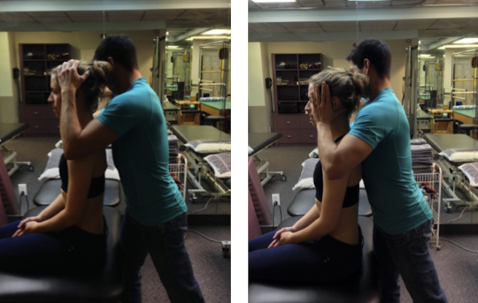
Mid and Lower thoracic spine: compress & distract through the shoulder girdle
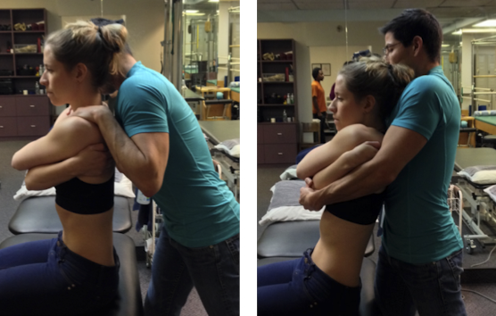
- Rib Springing:
  - Primarily performed to stress the anterior costal elements (sterno-manubrial, sternocostal, costochondral, and anterolateral rib body). Rib springing is very useful in testing the overall elasticity of the rib cage. Rigidity of the rib cage is often an early sign of osteoporosis and ankylosing spondylitis. Patients with COPD will also have + rib springing. Any sign of thoracic cage rigidity should be considered a contra-indication for manipulation.
  - (1) Supine : Apply a gentle, but rapid pressure through the hypothenar eminence upon the manubrium, just below the manubrio-sternal junction, and just above the xiphoid. If the test is positive for pain or clicking then you would perform a more detailed palpatory assessment of each of the costal elements.
  - (2) Prone: General mobility from top down and/or bottom up bilaterally, or unilaterally on one rib at a time with specific stabilization of the spine via the transverse process on the contralateral side (confirmation of a CVJ or CTJ lesion) (Dutton Vol 3; p.125).
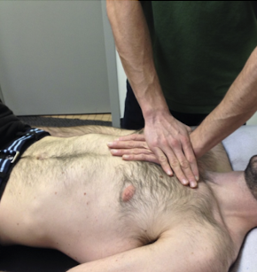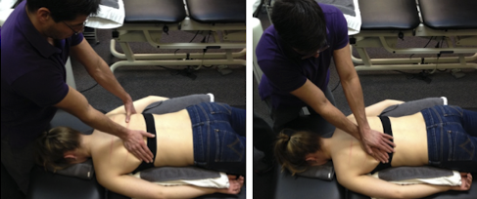

6. Localization of the dysfunctional joint w/in the spinal segment can be achieved by more accurate use of localized pressures or segmental stress tests:
PAVIMS
- PA to spinous or transverse process
- Rib springing, sternum
- Specific zygopophyseal and costal joint glides

- Provocative Test: A Posterior to Anterior pressure (perpendicular force to the bed) applied directly to the SP (e.g. - T5) stresses the structural integrity of the segment (T5/6). It applies an anterior shearing force to the target vertebrae (T5), while creating a relative posterior shearing force to the vertebrae above (T4) and the vertebrae below (T6). This shearing force may invoke spasm or pain in a reactive segment, which is a (+) spring test.
- Flexion/Extension test:
  - A cranially directed force to the superior SP will stress the segment in flexion
  - A cranially directed force to the inferior SP (i.e. two levels below the hypertonus) will stress the segment in extension
  - Directing the P/A pressures on adjacent SPs in a cranial or caudal direction can help to ascertain if the intervertebral lesion is in flexion or extension. Consider a localization of Sx by cranial pressure on the T6 SP.
  - This would stress extension at the T5/6 level, or flexion at the T6/7 level. If the T5 SP is then directed caudally and reproduces symptoms this tends to suggest an extension lesion at the T5/6 level, but only if pressure directed caudally on T7 alleviates or does not reproduce symptoms.
- Rotation Test: Apart from the P/A pressures mentioned above, one may also stress the intervertebral joints by rotational pressures (simultaneous pressure on opposite, adjacent transverse processes, e.g. left TP of T5 and right TP of T6, stressing right rotation at the T5/6 segment.
  - Place your thumb & 2nd middle phalanx over the TPs of the inferior segment (on the line of hypertonus, e.g. T6).
  - Use your thumb to seek out the angle of the rib above (i.e. left 5th rib) and use this landmark to find the TP of the superior vertebrae (e.g. left TP of T5).
  - Apply a P/A pressure by pressing straight down into the bed on both the T5 and T6 TPs simultaneously, producing a right rotation of the T5/6 segment
- Side-bending Test: A SB stress may be applied by superolateral stress on the SP, e.g. superolateral pressure at a 45° angle to the right side of the T6 SP, while stabilizing the T5 SP above, will stress left SB of the T5/6 segment.
- The SP of the superior vertebrae of the target segment (e.g. T5 is fixed by the therapists R index and middle fingers by applying pressure to the L side of the SP).
- Use your thumb to apply pressure to the R side of the T6 SP in a direction approx. 45° superolaterally. This is a left side-bending stress.
- Now move to the opposite side of the patient & repeat the above procedure from this side to produce R SB stress.
- Practice will make you more proficient at these techniques, but ultimately each suspected lesion can be confirmed by the use of PPIVMs with OP. The joint can thusly be confirmed or refuted as a pain generator, but also this technique also helps to determine if the cause of pain and hypertonus is joint hypomobility or hypermobility, or if the problem is in a spinal segment at all.
- Together, the above series of pressures are segmental stress tests that may help to rule out the presence of an unstable segment. The primary function of these tests is to assess stability and sensitivity of the posterior components of the thoracic cage. You should not feel any appreciable movement or crepitus with the stress tests. These should all have a hard end-feel. Further, we do not want to reproduce radiating pain or long-tracking signs. If sustained pressure reproduces symptoms in the legs or feet, further manual therapy is ill-advised, and entirely contraindicated in the presence of either a (+) SLUMP test or if there are UMN signs (e.g. Babinksi, Clonus).
PPIVMS
- Assess areas identified during active mobility testing as hypo- or hypermobile
- Palpate either interspinous space or TPs
- Apply overpressure to dysfunctional segments to determine end feel and symptom response
These tests are used when the therapist has found a painful or painless loss of motion in the thoracic spine movements of flexion, extension, rotation, or sidebending. For efficiency, you would only do the PPIVM’s on the segments identified by the bilateral hypertonicity in the scanning exam. Over-pressure is used to determine the end-feel and the symptom response. Identification of the type of lesion should be possible by careful palpation of the EF when over-pressure is applied to the segments of interest during PPIVMs
- Flexion – If you are standing on the patient’s right side, cradle his/her head or shoulder girdle in your R arm. Palpate between the SPs of each level with your L middle or index finger. Keeping the craniovertebral joints in neutral, flex the lower cervical spine until you find the motion arrive at your left finger. For OP, stabilize the lower segment and apply a gentle OP by pulling the superior segment through the head/neck superior/anteriorly.
- Extension - If you are standing on the patient’s right side, for extension, cradle the patient’s head or shoulder girdle in your R arm. Palpate the interspinous space of each level with your L hand. Keeping the patient’s craniovertberal joints flexed, use your R arm to extend the lower cervical spine until you feel the motion arrive at your L index finger. If you find a dysfunctional segment (hypomobile or hypermobile), overpressure by stabilizing the superior segment through the head/neck and push the lower segment superiorly/anteriorly under the superior segment.
- Side bending & Rotation – Once again, we will cradle the patient’s head/neck or shoulder girdle keeping the joints of the upper cervical spine in neutral. Gently SB or rotate down to and into the levels of the upper thorax that you are assessing. If there is a loss of either SB or rotation, we can retest the SB/rot PPIVM with the upper thorax in slight flexion or extension to determine which joint is restricted. If the patient exhibits a loss of R
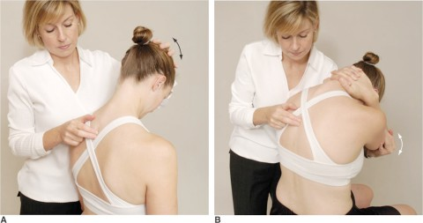
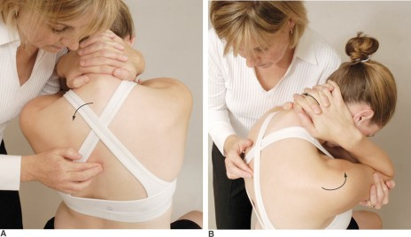
  - SB/rot that is worse with flexion of the head/neck, this tends to indicate that there is a joint on the L side that cannot open (e.g. the left facet joint cannot flex/R SB). If we were to find a loss of L SB that is worsened with extension, this tends to indicate that there is a joint on the L that cannot close (e.g. the left facet joint cannot ext/L SB).

